Solution:
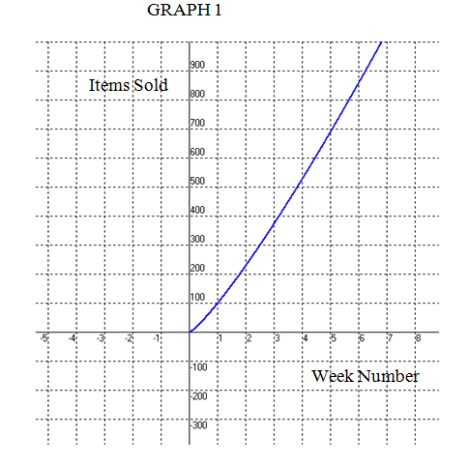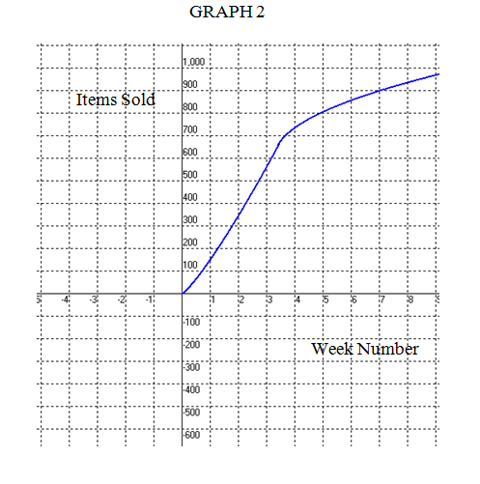
1) From the graph 2, we can see that at some point between the third and fourth week, the difference between the items sold in two consecutive weeks is lesser as compared to that of graph 1.
2) In both the graphs, as the number of weeks is increasing, the number of items sold is also increasing. So, both the graphs are increasing.
3) In both the graphs, the absolute minima is the number of items sold in the 1st week and the absolute maxima is the number of items sold in the last week.

If I were the store manager, I would have ordered the items shown in graph 1 more during week 9 as we can see from graph 1 that the number of items sold during week 9 will be more than 1000.Also, from graph 2, we can see that the number of items sold during week 9 is less than 1000.

